Technical Documentation for Organisation Hierarchy ETL

Organisation Hierarchy ETL is primarily driven by SSIS as the ETL tool with a Meta data driven control tables. Main control tables involved for the ETL are as below

ETL_LOAD_ENVIRONMENT

ETL_LOAD_TASK

ETL_LOAD_TASK_DETAIL

ETL_LOAD_TASK_MODULE

ETL_RULE_ENABLER

ETL_SCHEDULE_DISABLERS

ETL_TASK_CONTROL

## ETL Packages:

Below is the ETL Project with the packages as shown below

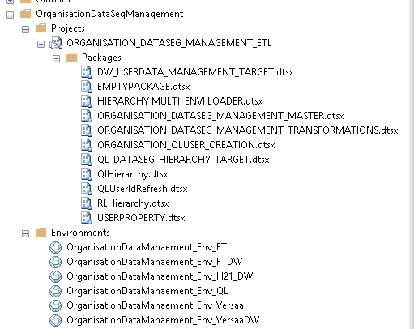

The ETL is scheduled to start with data transformations with the below package and then loads the target environment

ORGANISATION_DATASEG_MANAGEMENT_TRANSFORMATIONS

The target environment which can be QL FT& DW will be loaded either through the package ORGANISATION_DATASEG_MANAGEMENT_MASTER (Mainly for QL)or through the package

HIERARCHY MULTI ENVI LOADER pkg which can load FT   
& Versaa objects ,DW hierarchies and Workgroups & hierarchies

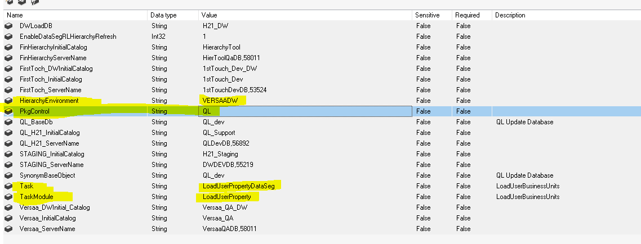

Setting the variables either ‘Hierarchy Environment’ or ‘Pkgcontrol ‘ sets the target load environment for the package flow which as ex below set to VersaaDW

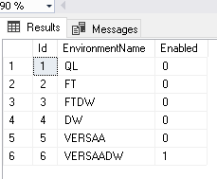

To load the subject area interested such as hierarchies for all environments or userproperty for FT&VERSAA set the project variables TASk & Task Module,in the below example sets userproperty load for versaa



Set ting the above variables will update the control tables below

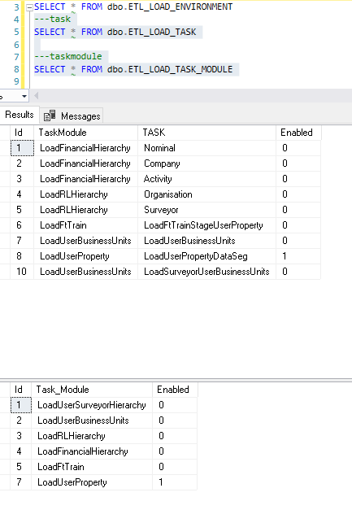

Setting the variable below Task variable ‘All’ and task module to ‘’LoadFinancialHierarchy’ will load all the financial hierarchies

